National University of Computer and Emerging Sciences



AL-2002: Artificial Intelligence
Lab Manual 05

Department of Computer Science
FAST-NU, Lahore, Pakistan

Table of Contents
Objectives 3
1 Informed Search Algorithms 3
1.1 What is a Heuristic? 3
1.2 Types of Informed Search Algorithms 4
2 Game Playing in Artificial Intelligence 5
2.1 Characteristics of Game Playing Problems 5
2.2 Game State Representation 6
2.3 Utility (Evaluation) Function 6
3 Minimax Algorithm 6
3.1 Node Representation 8

Objectives
After performing this lab, students shall be able to understand implementation of the following :
- Informed (heuristic-based) search algorithms:Greedy BFS, A*
- Game Playing using minimax algorithm

Informed Search Algorithms
Informed search algorithms (also called heuristic search algorithms) are search techniques that use additional problem-specific knowledge to guide the search toward the goal more efficiently.

Unlike blind search algorithms, informed search algorithms use a heuristic function to estimate how close a given state is to the goal.

They make use of:
- Initial state
- Goal state
- Actions available between states
- Heuristic information

What is a Heuristic?
A heuristic function, usually denoted as h(n), estimates the cost from a node n to the goal.
Properties of a heuristic:
- It is problem-specific
- It provides guidance, not certainty
- A good heuristic improves efficiency
Examples:
- Straight-line distance in map navigation
- Number of misplaced tiles in 8-puzzle
- Manhattan distance in grid problems

1.1.1 Heuristic Function in Python
A heuristic is typically implemented as a dictionary or a function:

heuristic = {
'A': 6,
'B': 4,
'C': 2,
'D': 3,
'E': 1,
'G': 0
}
or
def h(state):
return heuristic[state]

Types of Informed Search Algorithms

1.2.1 Greedy Best-First Search (GBFS)
Greedy Best-First Search expands the node that appears closest to the goal, based only on the heuristic value.
Evaluation function: f(n) = h(n)
GBFS ignores the path cost and focuses solely on the estimated distance to the goal.
- Create a priority queue ordered by h(n)
- Insert the initial node
- While the queue is not empty:
- Remove the node with the smallest h(n)
- Check if it is the goal
- Expand neighbors
- Add unexplored neighbors to the queue

1.2.2 A* Search Algorithm
A* is one of the most important and widely used search algorithms. It combines the strengths of Uniform Cost Search and Greedy Best-First Search.
Evaluation function: f(n) = g(n) + h(n)
Where:
- g(n): Cost from start node to node n
- h(n): Estimated cost from n to goal
A* selects the node with the lowest total estimated cost.
- Create a priority queue ordered by f(n)
- Insert the initial node with cost 0
- While the queue is not empty:
- Pop the node with lowest f(n)
- Check if it is the goal
- Expand neighbors
- Compute new g(n), h(n), and f(n)
- Update queue if a better path is found
In summary:

Algorithm | Evaluation Function | Optimal | Complete | Memory
GBFS | h(n) | No | No | Low
A* | g(n) + h(n) | Yes | Yes | High

Game Playing in Artificial Intelligence

Game playing is one of the classical problems in Artificial Intelligence. In game-playing problems, an intelligent agent must make decisions by considering possible future moves and the responses of an opponent.

These problems are usually modeled as:
- Two-player
- Turn-based
- Zero-sum games

Examples include:
- Tic-Tac-Toe
- Chess
- Checkers
- Connect Four

Characteristics of Game Playing Problems

- There are two players:
  - MAX (the AI or computer)
  - MIN (the opponent)
- Players take turns
- One player’s gain is the other player’s loss
- Both players are assumed to play optimally

Game State Representation
In game playing:
- A state represents a configuration of the game board
- The initial state is the starting position
- Terminal states are game-ending positions (win, lose, or draw)
- Each state has possible actions leading to new states
The game is represented as a game tree.

2.2.1 Game Tree
A game tree is a tree structure where:

- Each node represents a game state
- Each edge represents a possible move
- Levels of the tree alternate between MAX and MIN players
- MAX nodes: try to maximize the score
- MIN nodes: try to minimize the score

Utility (Evaluation) Function
At terminal states, a utility function assigns a numeric value indicating the outcome of the game. Typical utility values:
- Win for MAX: +1 (or positive value)
- Loss for MAX: −1 (or negative value)
- Draw: 0

Minimax Algorithm

The Minimax algorithm is a recursive decision-making algorithm used for optimal play in two-player games.
It assumes:
- Both players play optimally
- MAX tries to maximize the utility
- MIN tries to minimize the utility

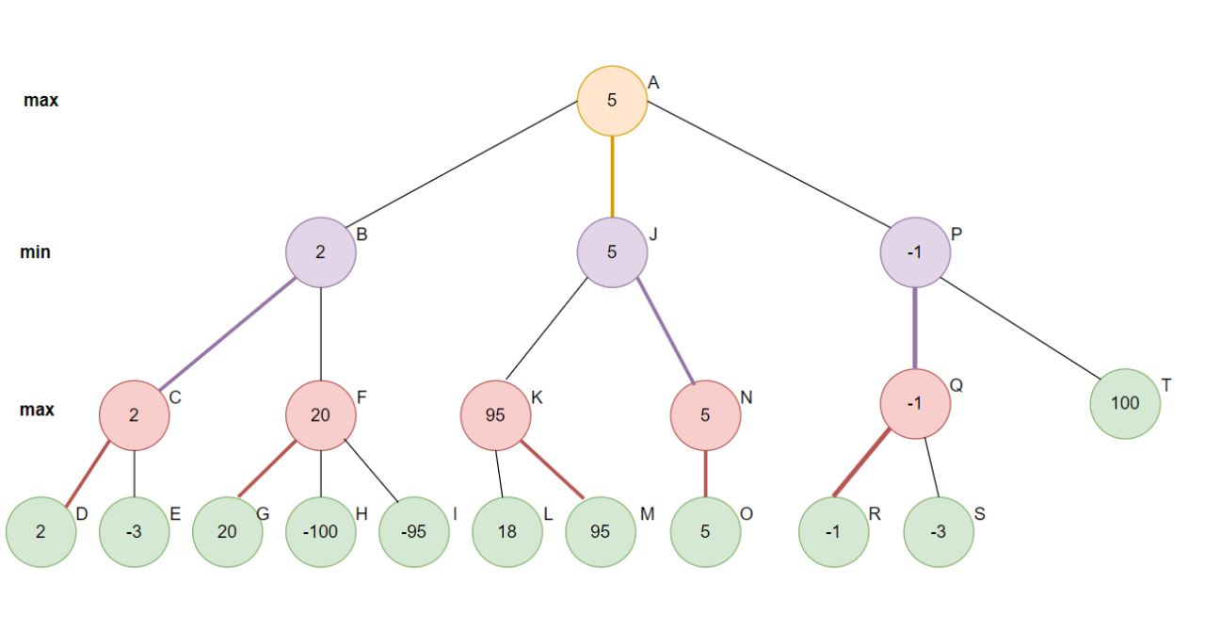

Algorithm:
- Start from the root node
- If the node is a terminal state:
  - Return its utility value
- If it is MAX’s turn:
  - Evaluate all child nodes
  - Return the maximum value
- If it is MIN’s turn:
  - Evaluate all child nodes
  - Return the minimum value

MINIMAX(node, depth, isMaxPlayer):

if node is terminal or depth == 0:
return utility(node)

if isMaxPlayer:
bestValue = -∞
for each child of node:
value = MINIMAX(child, depth-1, False)
bestValue = max(bestValue, value)
return bestValue

else:
bestValue = +∞
for each child of node:
value = MINIMAX(child, depth-1, True)
bestValue = min(bestValue, value)
return bestValue

Node Representation

A node in a game tree may contain:
- Game state
- List of possible moves
- Player type (MAX or MIN)
- Utility value (for terminal nodes)

For example:

class Node:
def __init__(self, value=None, children=None):
self.value = value
self.children = children
Q1 — Heuristic & Greedy Best-First Search (GBFS)
Implement Greedy Best-First Search on a graph of cities using heuristic values (straight-line distance to goal). Find the path from A → G.
----------------------
Q2 — A Search Algorithm*
Implement A* search for a weighted graph using adjacency list + heuristic. Show the path, total cost, and nodes expanded.
----------------------
Q3 — 8-Puzzle Heuristics
Implement two heuristic functions for the 8-Puzzle problem:
- Number of misplaced tiles
- Manhattan distance
Compare which heuristic performs better in finding the goal state.
----------------------
Q4 — Tic-Tac-Toe Game Representation & Utility
Design a Python representation for a Tic-Tac-Toe board:
- Represent the board as a state
- Generate all possible moves from a given state
- Detect terminal states (win/lose/draw)
- Write a utility function: +1 → AI wins, -1 → Opponent wins, 0 → Draw/ongoing
----------------------
Q5 — Minimax Algorithm & Game Tree
Implement the Minimax algorithm for Tic-Tac-Toe using a Node class:
- Simulate MAX (AI) vs MIN (Human)
- Compute the optimal move for AI
- Display the best move selected and the Minimax values in the game tree

